**Detox Diet: Clean Away Toxins**

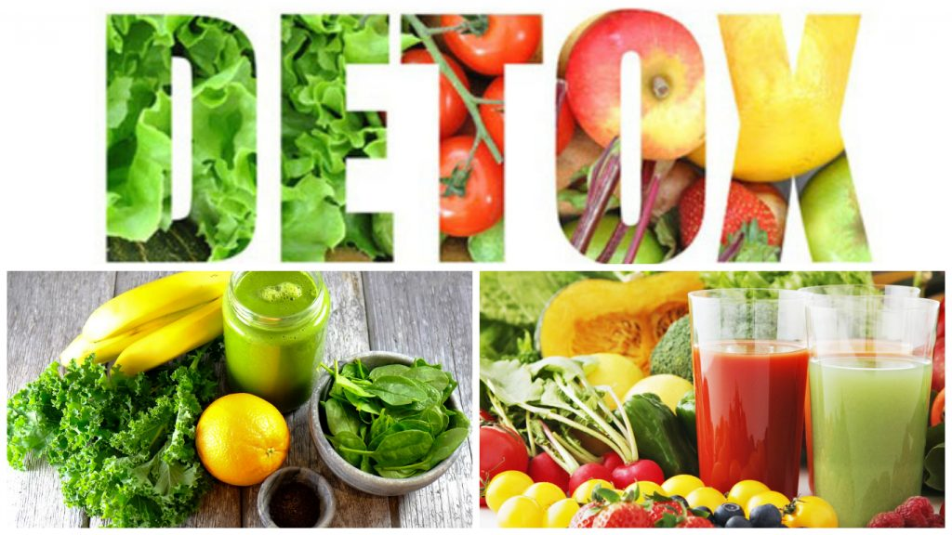

A common quote you are going to find nearly every time you search for ‘How To Reduce Weight’ is: “Utilize the calories you take in”. Today’s diet consists of a variety of fantasy wells we opt to jump into! Without noticing the side effects they bring home. Is it really a difficult task to burn calories? Or is it just overrated? Sometimes, we are too afraid to even give it a try. That's what we need to conquer!

**What is a detox diet?**

Detox diet is an unusual diet plan including important and beneficial food components to refresh your body, internally and externally both! It contains a healthy bunch, specifically, fruits, vegetables, proteins, whole grains and a huge amount of liquids (soups, low fat milk, green tea and WATER!).

**What is the necessity? How does detox diet benefits our body?**

A garden looks greener if it is taken care of. Similarly, a body looks more radiant if it is taken care of, internally and externally. People ponder upon outer appearances while inner health is far more important to look and live best!

Detox diet benefits your inner body organs and cleanses it to the root, giving you full access to your own body!

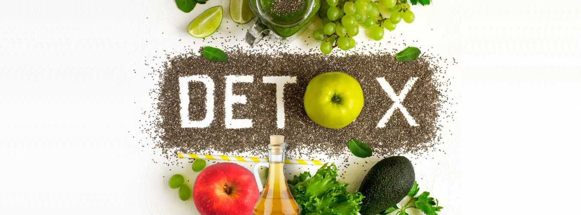

**What to do to enjoy Detox diet benefits?**

Act before the clock stops ticking! Detox diet benefits you by:

* ‌enhancing blood circulation

Blood carries oxygen to parts of the body and carries out deoxygenated blood back to heart for cleansing. If the flow is not smooth, it can lead to blood clotting and at advanced stages, cancer.

* giving massage to internal organs

Every organ in our body works 24/7 to keep us alive. Liver, lungs, heart, kidneys are not to be constrained by unhealthy eating habits. A detoxification benefits them, relaxes them and allows them to perform better.

* ‌eliminating toxins from the body

A spa relaxes the tensed muscles and so does a detoxification treatment relaxes the body tissues.

**Steps to count on a regained healthy lifestyle**

Ready? Set. Go! Plan a detox diet yourself keeping in mind issues us suffer from. Detoxification benefits in various ways but it can be proven hazardous to some! For example, a Diabetic patient can't be restricted to eat for more than 2 hours. Or a weak kidney patient has to limit the excessive fluids intake.

**Detoxification side effects**

The term 'Detox Diet Side Effects' might get induced even if you are following the diet properly, reason being instant elimination of saturated fats and oils.

A good habit is difficult to take over and consequently our body functions contrary when on a detoxification treatment. The body may not support initially. Detox diet side effects may creep in like loosing energy, feeling dizzy all the time, low blood sugar and muscle aches may follow. But once passing the initial stage, it gets used to the detoxification treatment and would work more effectively comparatively.

It requires hard work to protect a plant from damage but once it blossoms, only sweet fragrance is spread all over. And like weeds, Detox diet side effects must be minded and sincerely removed.

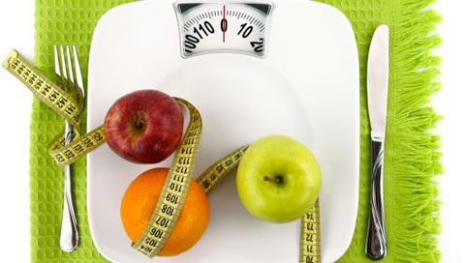

**Detoxification treatment**

The detoxification treatment methods are provided as a backup! Experiencing ups and downs on a regular basis? Not to worry!

Detoxification side effects may lower your strength but not the determination in you! Detox diet benefits may ignite your will to stay strong!

* ‌Use ice packs to cool those achy muscles.
* ‌Increase intake of light fluids to stay full stomach.
* ‌Scraping off tongue while brushing rescues from bad breath.

On a serious note, Detoxification side effects must be checked beforehand!

Energise yourself and swear to take full advantage of detoxification benefits to lead an ideal life!